Mehmet Açıkalın

A Social Studies Education Lesson from Turkey:
Human Rights

Key Words: Social studies; Human rights; Citizenship education; Turkey.

Introduction

Social studies is a field, consisting of wide variety subjects, and the content of this field differ from one country to another. Also, how social studies are taught may differ a lot depending on each country’s culture and educational settings. Thus, it would be very interesting to see examples of social studies lessons from various countries to understand differences and similarities regarding how social studies are taught in different parts of the world.

Therefore, an example of a social studies lesson from Turkish educational context is provided for the special issue of Journal of Social Science Education. This may be the first recorded and transcribed social studies lesson from Turkey. To my knowledge there is no other example to date of a completely recorded and transcribed social studies lesson from Turkey. Thus, this study provides an example of a social studies lesson from Turkey in order to facilitate comparison with examples of social studies lessons from other parts of the world.

This lesson was recorded in a 7th grade class at a middle school in one of the metropolitan neighborhoods in Istanbul. According to the current curriculum in Turkey, social studies education is an interdisciplinary field (TTKB, 2009b; 2009c). The subjects of social studies include history, geography, economics, sociology, anthropology, psychology, philosophy, political science, law, and civics (TTKB, 2009b; 2009c). Social studies courses are taught under two different titles in elementary and middle schools from the first through seventh grades in Turkey. In early grades (grades 1-3), the course is called Life Studies (see TTKB, 2009a) and, from grades four through seven, it is called Social Studies (TTKB, 2009b; 2009c). Both courses are interdisciplinary, focusing on skills and values that promote effective citizenship for the Turkish nation. At the high school level (Grades 9-12), social studies subjects are taught as discipline based courses such as history, geography, sociology, psychology, and philosophy.

Bio Statement: He is an associate professor in the Department of Social Studies Education at Istanbul University, Turkey. He received his PhD from The Ohio State University, USA in 2006. His research interests are computer-supported instruction in social studies and teacher education.

Finding a school site

Finding a school site and teacher participants was one of the major methodological issues for this study. This study is not typical educational research and it is not well known by the school administrators and teachers in Turkey. Educational research studies in Turkey are dominated by surveys and questionnaires. Thus, generally school administrators and teachers limit educational research only to these kinds of surveys which they call “anket”. Anket is originally a French word “enquête” and has been integrated into Turkish to mean “public poll” or “questionnaire”. Therefore, this type of educational research which required a video recording of a class session was unconventional for the school administrators and teachers and they were not eager to participate in this research. Initially, I was turned down by a couple of schools. Eventually, I was able to convince a social studies teacher and his principal to participate in the study. Of course, it was not enough to get permission from the school. I also applied to the school district for their permission. I was also worried that the school district would not allow the recording as it was a different research method to those generally approved. Like school principals and teachers, administrators in the school districts were also used to approving research studies that required applications of “ankets”. Nevertheless, I managed to obtain permission for the study from the school district within a four week period.

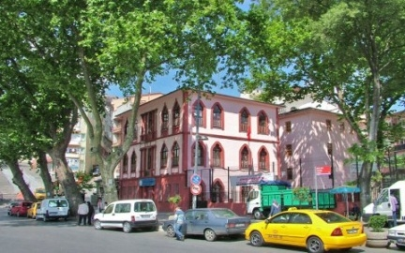

The school.

The School

This public middle school is located in one of the central regions of Istanbul. It is a two storey historical building which was built in the 18th century. The building was used by the navy during the Ottoman period. It is very common to see such historical school buildings in Istanbul especially around the old city. Such constructions, including this one, usually were not designed as school buildings originally which results in limited spaces within the classrooms, offices, playgrounds, and other facilities in the school. Another problem with the school concerns its location. Since the school is located within metropolitan area, a lot of noise that can be heard during the class sessions. The school had 450 students at the onset of the study. The observed class population was 27 (16 male and 11 female) students. According to the school principal and the social studies teacher, students’ families’ socio-economic status while heterogonous can be considered middle and upper middle class.

The Teacher

The teacher is a 34 year old male. He graduated from a history teacher education program in one of the large universities in a metropolitan city. Although he graduated from a history teacher education program, he was appointed as a social studies teacher. Since there was a shortage of social studies teachers at that time, he was appointed to social studies by the Ministry of National Education in one of the public schools. He has 12 years teaching experience. He taught for one year in Bingöl, a city located at the Eastern region of Turkey and had worked in the school where this study took place for 10 years. He has just transferred to another middle school in Istanbul at the beginning of this academic year.

The lesson: Methodological process

The lesson topic was human rights which is a core topic in social studies education. This topic was selected because it is a common topic often associated with social studies and civic education curricula worldwide. Therefore, presenting a social studies lesson with a topic of “human rights” might be easier for teachers and scholars worldwide to follow and understand. Also this lesson might be more valuable for teachers and scholars worldwide as it provides an opportunity to show how this universal topic is taught in a Turkish educational context and allows them to compare this lesson bearing in mind their countries’ educational context.

The lesson was video recorded and transcribed verbatim. Then, the transcripts in Turkish were translated into English. Explanations were given in brackets when necessary. Transcription and translation process were not easy. Some issues came up especially with the translation as some words lose their meaning when translated to English. But before that I would like to give some information about key features of the lesson. When you read the whole text, you will see that the teacher always repeated what the students had said. Repeating students’ responses might make the lesson boring for the readers. But this is typical in a social studies lesson in a Turkish educational context. Social studies teachers generally repeat or rephrase what the students say to make it clear for the rest of the class.

Another thing concerns how students address their teachers. Students do not call teachers by their first or last names. Instead, they use a single word, “Hocam” [my teacher]. As you can see from the Turkish version of the transcripts, students used the word “Hocam” many times (31 times) during the lesson. But, I did not translate it every time, because most of the time it did not make much sense when this word was translated to English. There were also other words used frequently in the transcripts. One of them was “başka?” [What else?]. The teacher used this word 42 times in the lesson in order to elicit various answers from his students. As can be seen from the text, the teacher used a question & answer method extensively. Thus, he asked students “başka?” too many times. Another extensively used word was “şey” [something /thing]. It was used 39 times in this lesson. It is both difficult and easy to translate this word in a sentence. “Şey” can be used as a substitute word for almost any word in Turkish. I, in most cases, translated “şey” as “something” or “thing”. But in some cases I had to omit the word from the English translation. More information about translation or context is given within brackets.

Two sessions covering the same topic were recorded. Nevertheless, for reasons of space, only the first session was prepared for this issue with a summary of the second lesson provided.

Outline of the First Lesson and Seating Plan

The teacher started the lesson by asking what human rights meant to the students. For most of the lesson, the teachers asked the students questions and got answers from them. The key points discussed in the lesson were:

- various human rights such as the “right to settle /shelter”, “right to vote and get elected”.
- human rights violations and racial discrimination.
- violence towards women (March 8 - International Women’s day)
- modern colonization (Some students believe that the U.S.A. exploits other countries such as Afghanistan and Iraq).
- the right to life and how this right can be violated (Wars, blood revenge, assassination, and murder, ext.)

- the right to receive healthcare, property rights, and the right to travel.
- the right to communicate (Tapping phones illegally: Teacher gave life of Howard Zinn as an example for that. When Howard Zinn wrote his autobiography, he asked the FBI for his personal file which included all of his telephone conversations and other forms of communication, everything related to his life)
- discrimination between rich and poor (Teacher gave example of police searching random teenagers on the street and he suspected that the police particularly choose these boys mostly because of their poor clothing and appearance. The teacher discussed that with the students)
- violation of private life (paparazzi shows)

The seating plan for the lesson was as follows:

Summary of the Second Lesson

The second session of the lesson basically followed a similar structure to the first session. Most of the lesson was also allocated to questions & answers. The teacher showed students several pictures associated with human rights violation in this session and had the students analyze the pictures. Below are examples of these pictures.

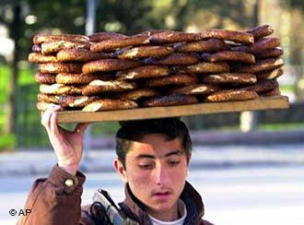

Picture 1: Kids who sell “simit” [Turkish bagel]. (Showing this image, the teacher guided a classroom discussion about underage children working).

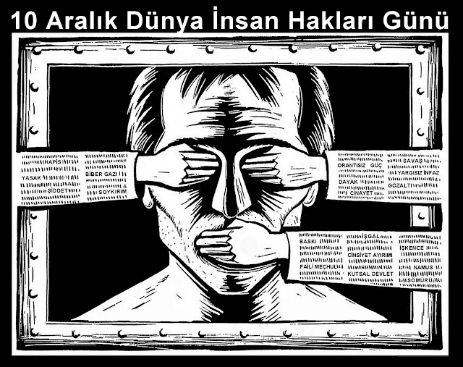

Picture 2: 10th December Human Rights Day (Showing this image, the teacher guided a classroom discussion about various human rights violations such as violence, torture, and limiting of freedom of speech).

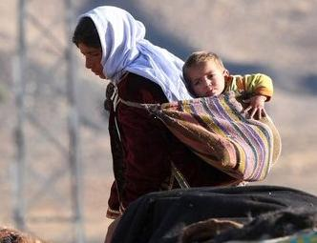

Picture 3: A beggar woman with a child (Showing this image, the teacher guided a classroom discussion regarding how this child’s human rights were being violated)

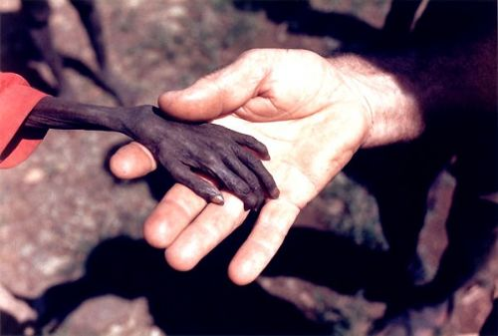

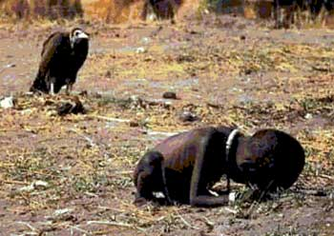

Pictures 4 & 5: Human hunger in Africa. (Using these images, the teacher guided a classroom discussion regarding hunger as violation of human rights and our responsibility as a whole world for this hunger)

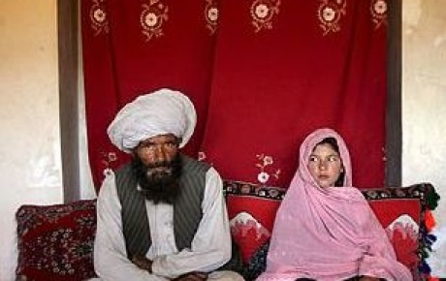

Picture 6: Underage girl’s marriage (Showing this image, the teacher guided a classroom discussion regarding underage girl’s marriage as a violation of human rights).

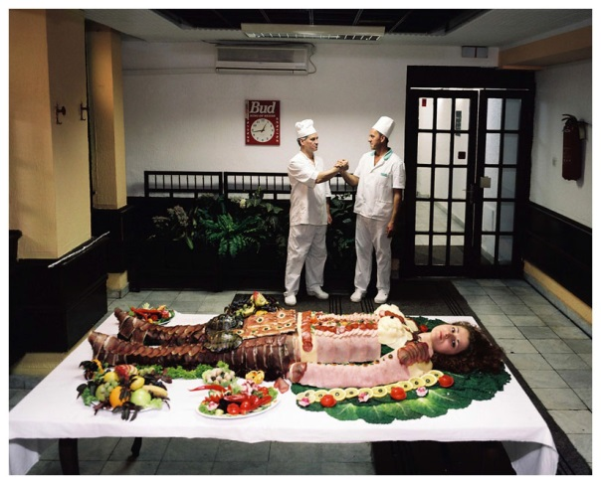

Picture 7: Woman’s body in a sushi bar (Showing this image, teacher guided a classroom discussion regarding using woman’s body for commercial purposes which is another violation of human rights).

Transcription of the first human rights lesson
Abbreviations / Explanations:
T: Teacher, S: Students
SF: Female student, SM: Male students
In order to indicate the students who contributed most to the classroom discussion, pseudonyms are used (Female names: Gamze, Tuba, Senem; Male Names: Bora, Can, Ferit, Mahir, Yavuz)

T: Alright… children today’s class topic is “Human rights and its origins”. I guess we have been hearing the expression “human rights” frequently these days. What do you think about human rights? What are human rights?
S: … [3 sec]
T: Human, what is a human?
Mahir: I will talk about human rights. Human rights are essential needs. For example there is something essential. For instance, one of the rights is the right to shelter.
T: Yes.
Mahir: For example, the right to education.
T: Actually, let’s have a look at the root of the issue. What is a human?… Human? What are you? [Asks a student.]
SM: A human.
T: You are a human. What am I?
SM: A human.
T: Your friends and I… everybody in this classroom is a human. So what is a human?
S: …
T: Have you ever asked yourself this question? Yes. [Picks a student.]
Bora: A living being.
T: A living being… If you look at it this way, the cat at home is also a living being.
Yavuz: The smartest living being.
T: The smartest living being! So, it must be “a living being” and “smart” at the same time. Is it like that?… Ok. The smartest living being. So is the human being different from other species and living beings?
Yavuz: Yes.
T: Ok. They are different. What do we call this? It is also in the Koran. What does it say? Or it is also in other religions’ holy books. What does it say in the Koran? It says the human being is the most honorable creature in the world [eşrefi mahlukat]. Where does this honor come from?... From their [humans’] thinking. Ok, human… what are human rights?
Can: The right to live.
T: The right to live. What else?
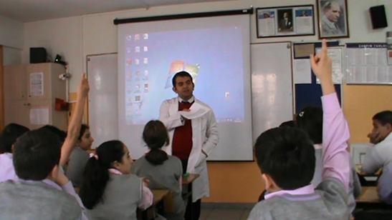
Photo 1: The teacher is asking a question.

SM: The right to settle/shelter.
T: The right to settle. What else?
SM: The right to elect and be elected.
T: The right to elect and be elected. What do you mean by that? Do you mean selection / voting for anything or for political reasons or selection relating to any aspect of life?
SM: [Relating to] every aspect of life.
T: What, for example, do we have to select in our lives? Have you ever thought about that? What do we have to select in our lives?
Yavuz: The president.
T: The president. What else?
Bora: I was going to say the same thing. But my friend has already mentioned it.
T: In fact, the expression of selection is modeled in our heads. And we always say the same thing. Either we are selecting the leader of a political party or the class president. Does a human not have any other right to select?
S: …
T: Does s/he not have the right to select anybody / anything other than those people to govern him/her?
SM: A human can select his/her religion.
T: What else? S/he can select his/her religion. What else?
SM: S/he can select the place to live.
T: S/he can select the place to live. What else?
S: … [3 s]
T: [A person] can select the apple s/he wants to eat from the supermarket, right? S/he can select whatever vegetable s/he wants to eat from the market. A human can select the person whom s/he wants to get married to. S/he can select the school s/he wants to go to. Who is the only person that s/he cannot choose?
S: … [7 s]
T: Did you say something?
Tuba: His/her parents.
T: [A human] cannot select his/her parents. Alright, we have talked about the rights of a human so far. One of them is the right to vote and to get elected. Humans are entitled to rights as soon as they are born. What is the first [of these human rights]?
S: It is the right to live. [Altogether. It is very common to see that all students or at least a group of students respond altogether. This is observed several times in this lesson.]
T: The right to live. The right to live. Ok. Who are those that invade human rights? Who violates human rights?
SM: Humans.
T: Godzilla or the humans? [Laughing.]
SM: The humans.
T: Humans deprive other humans of their rights. Ok then, how do these humans take over other humans’ rights?
S: … [2 sec]
Bora: They do not vest/acknowledge rights.
T: For example? For example? It is not necessary to give such big examples. Give examples from your own lives.
Ferit: Not all people are treated equally.
T: Who do you mean, for instance? Are you and I not equal?
Ferit: Yes teacher, we are... But the people who violate human rights…
T: Segregate/discriminate between who and whom? For example, tell me about something that caught your eye.
Ferit: For instance, Primeminister and a person who lives in a village.
T: [They discriminate between] Prime minister and a villager. Why do you believe in that?
Ferit: Because of the photo, my teacher... [He points to the photos on the screen.]
T: Photo? Is there anything about that [on these photos]?
Ferit: Teacher, for example there is one kid lying on the ground and no one helping him.
T: Ok! Let’s come back to the pictures later. Let me close that down, because we are going to talk about these pictures separately. Is there anything you see or feel? Do not look at the photographs. Yes?
Yavuz: Teacher, the color of skin.
T: Color of skin. For example, you have a light skin, I have a chocolate skin color. So, does this mean you and I are not equal? Are we? Is a dark-skinned person better [than a light-skinned person]?
Yavuz: Teacher, they discriminate [because of skin color].
T: Is there something like that?
Yavuz: Yes, there is, teacher.
T: Where?
Yavuz: Almost in every country, my teacher.
T: So when you talk about skin color you mean… blackish [Teacher used word “siyahi” means “blackish.” “Siyah” means black color] people or in more impolite term “Negroes”? [Teacher here used the word “Zenci”, the impolite way to refers the black race]
Yavuz: Yes.
T: Negroes. So, who discriminates [between white and black people]? Do we do that? [He means the Turkish Nation]
Yavuz: Teacher, personal… it is a personal [subjective] thing.
T: It is something personal. Ok, are there a lot of Negros in our country?
Yavuz: Not many.
T: Not many. But their [the illegal African immigrants] numbers have been increasing, right? So do you think we are developing prejudice against these people? Or do you feel that prejudice against these people is developing in society?
Yavuz: No.
T: You do not. Ok then, is there any human rights violation in the society you live in?
Yavuz: Yes, there is.
T: For example what kind?
Yavuz: Teacher, there are people who are involved in racial discrimination.
T: Racial discrimination... They engage in racial discrimination. What else?
S: [incomprehensible]
T: In any a case, a person who praises his/her race is a racist. So you say, there is one race in this country and there are people defending that race… Are there just racists of one and the same race in this country?
Yavuz: No.
T: So, you say in this country there are racist people of each nation living here [who belong to different ethnic groups]. And you say there are racists within all races in the world. Yes. What else? Other human rights violations? Yes?
Tuba: Violence against women.
T: Violence against women. Yes… When was the issue most popular? Which day was it in March? It has been discussed a lot.
Senem: March 8.
T: March 8. What is March 8?
Senem: World workers women’s day. [Senem here originally said “Dünya emekçi kadınlar günü” meaning “World workers women’s day”. It is, in fact, “International Women’s Day”. In Turkey, March 8 mostly is valued by the leftists groups. Thus, there is a special emphasis on the word “workers”]
T: World workers women’s day. Ok, let’s continue. Violence against women. Do you see other human rights violations? Yes?
SF: In the past, Kings and religious people [Priest, imam etc.] were entitled to more rights…
T: In the past!
SF: … than the regular people.
T: But, is there any human right violation you can see today? We are going to talk about that [later]. We are going to talk about the [historical] development of human rights [later]. But, is there any human rights violation you see today? Yes.
Tuba: Torturing animals.
T: Torturing animals. Actually, isn’t that something different. This is not violation of human rights. Rights of living beings. Here a new rights expression arises. This means, rights of living beings. Let us talk about that separately.
Yavuz: Colony [The word “Colony” does not refer its literal meaning in this context. It refers to exploitation].
T: What colony?
Yavuz: Some countries exploit other countries.
T: Are there still colonized countries?
Yavuz: There are.
T: For example?
Yavuz: Afghanistan, for example.
T: Afghanistan. Who exploits Afghanistan?
Yavuz: America [People in Turkey when they talk about the United States, they refer her only with one word as “Amerika” which is the Turkish form of “America”].
T: America exploits Afghanistan. Ok, America. Then, according to your logic, America also exploits Iraq, right? So what does it take from Iraq?
Yavuz: Petroleum.
T: It [USA] takes petroleum [from Iraq]. Ok then in the world as we can just see from TV and read from newspapers, if I ask you to name a country that supports human rights, which country would that be? In all respects. Can you tell me one country that will be there with their people and government, if there is any human rights violation anywhere in the world? Is there any country that you can name?
Bora: I do not think there is.
T: Isn’t there? That cannot be true! On the grounds of human rights violation people [nations or countries on the world] send their armies back and forth.
Yavuz: Turkey.
T: Turkey! So you say Turkey is a sensitive country for human rights violations in the world and wherever there is human rights violation Turkey would be there! Is that what you were saying?
Yavuz: No. Actually, not that much...
T: So you say we just get sad.
Yavuz: Supposedly.
T: We condemn [when we see human rights violations]. Is there such a country?
S: … [6 sec]
T: Yes. Is there such a country?
S: …
T: So there is not. Then, I will briefly give some information about this issue. After that let us have a look at why there is or there is not a country sensitive to human rights violations and where the mistake is? Now… What are human rights? In a general sense, everybody is entitled to human rights as soon as s/he is born. Once you were born and took your first breath, what is your first human right? It is the right to continue breathing. It is the right to continue breathing. Nobody in the world can take your right to breathe, this means your right to live, from you. Ok, when we look at this in detail, what is the right to live? How can the right to live be taken from somebody?
Bora: By being killed.
T: How does a person get killed? Under what circumstances can s/he get killed? There can be a murder, there can be a fighting... What else?
Bora: Wars.
T: Hah. Yes, wars. What else?
Can: Blood revenge. [It is a long-running argument or fight, often between social groups of people, especially families or clans. Although it has been diminishing, there are still ongoing disputes between families in the eastern parts of Turkey.]
T: Blood revenge. What else?
SM: Assassination.
T: Assassination. What else?
S: … [2 sec]
T: Ok, let’s go to another point. Let’s say an earthquake has happened and a large site built by a contractor collapsed due to using unqualified or limited material for the construction. As many people get killed under this building, would this be a human rights violation or the deprivation of the right to live? What do you think? Do you know anybody who got killed in an earthquake? There is somebody in the other class, for instance. I will not give his/her name. S/he has lost his/her uncle, aunt, and all his/her cousins. Here there is a violation of human rights and additionally murder! Isn’t there? The right to live… Right to receive healthcare! What is the right to receive healthcare?
Can: It means people can go the health centers or hospital to get information about their health.
T: To get information about their health. What else? What is the right to receive healthcare?
S: … [5 sec]
T: Do you go to the doctor?
S: Yes. [Altogether]
T: Yes, you do. Do you have right to receive treatment?
S: Yes. [Altogether]
T: Yes, you have. Ok then, this is your first essential healthcare right. If you are sick and there is a treatment, you have to get this treatment. Ok, would big corporations and their activities which endanger your health and your lives also be considered a violation of right to health? For example, there is a factory in your neighborhood and this factory does not have a filtering system necessary to prevent air pollution. The factory continuously releases unfiltered bad smoke, toxins and chemical gases to nature. Do these affect peoples’ health?
S: Yes. [Altogether]
T: And because of this, would a person’s right to health be violated?
S: Yes. [Altogether]
T: Do you think there is a violation of human rights in this case?
S: Yes. [Altogether]
T: Yes, there is. Can you give another example for that? Yes.
Bora: Cigarettes.
T: Cigarettes! It is an interesting example. Ok, who is involved in this case?
Bora: What do you mean by involved, teacher?
T: I mean smoking cigarettes is a health right, a violation of the health right. But for example… I give you an example. A person named Ahmet smokes, but he goes to buy his cigarettes himself. Where is the violation here?
Bora: Is it within the state, teacher?
T: You tell me. Think about it. Where is it [the violation]?
Bora: … [3 sec] The state, teacher.
T: Let me give you a hint. He has given a good example. He said the state was responsible. Let me give you a hint. In fact, people’s habits are all taught somehow. I mean, if you never see cigarettes in your life, you would never want to smoke and you would not know what cigarettes are. If you had never seen ice cream in your life and if you had never seen people eating ice cream, what would you do? You would not want to have ice cream. Then, are there any factors that affect us in starting smoking habits? Yes.
Can: Family.
T: How? Give me an example.
Can: If a child’s or teenager’s parents smoke s/he may be curious [about smoking] as well.
T: What else? Family is right.
Bora: Friends.
T: What else?
Bora: People around the person.
T: What else? People around the person. I will add one more. Television. Another human right… one of the primary human rights is the right to property. What is property?
Mahir: Residence, home.
T: Residence, home. Ok, it means a person can buy any house that s/he wishes within the law. Another human right is the right to travel. Is there a human right called a right to travel?
SM: There is.
T: There is. We can travel wherever we want. Ok, can we travel wherever we want?
S: … [2 sec]
T: Can we travel wherever we want?
Bora: Yes.
T: Ok, where do we go? You say yes. Where do we travel? Where can we go?
Mahir: Anywhere within the country.
T: We can. Is there anybody who travels? Is there anybody who can travel? You travel. [Speaking to a student] Where have you traveled?
SF: Antalya … Bodrum. [Well known travel destinations in the coastal area of Turkey]
T: Antalya, Bodrum. You went for vacation. Where else? You?
Bora: Edirne. [A city in the Northwest of Turkey]
T: Has anybody stopped you from traveling?
SFM: No.
T: Then, is this issue a problem in our country?
S: No. [Altogether]
T: Ok, we can say it is not an issue. Of course we talk for our country. Ok then… How can a person’s right to travel be prevented? Yes?
Yavuz: If s/he has committed a crime, if s/he is a felon [ex-convict].
T: These are legal reasons. It means this felon violated another person’s right (i.e. right to health; right to live)... This guy is a felon and thus is, by law, deprived of his rights to travel, to own property, and even to live freely. But, I am talking about us here who (presumably) have no obstacles to travelling. How can anybody take away our rights to travel?… If they take our rights to travel, would that be right? Let’s say you are going to Bodrum by car or by bus and somebody gets in front of your vehicle with his/her gun or with something else and stops you and tells you “no, you cannot go further”. Would s/he have deprived you of your right to travel?
S: Yes. [Altogether]
T: Would s/he?
S: Yes. [Altogether]
T: Ok then, has this happened in this country before?
S: Yes.
T: Where did it happen?
S: …
T: You say yes. But tell me where?… Ok, all of you are not old enough to remember that. There was a time when this happened before in the Eastern parts of Turkey. Lawless people built barriers on the road and said to travelers that they weren’t allowed to continue their travelling from this point on. So, these lawless people took away other people’s right to travel. Another right we have is the right to communicate. What is the right to communicate?… What is the right to communicate? Yes, tell me.
Senem: Is it seeing other people and talking with them?
T: Seeing?
Senem: And talking with other people.
T: Seeing other people and talking with them, actually to get in touch with other people; get to communicate with other people. As it is in the word “communication”, to interact with others, to receive information and to give information. This is the right to communicate. Can we make use of our right to communicate as we wish?
SF: Yes.
T: How do we use our right to communicate? Yes, we are experts on this issue. [Meaning the students] Yes, please.
SM: Telephone.
T: Telephone. Is it only telephone? What else?
Tuba: Computer.
T: Computer. But what are the applications, the instruments that are used with the computer in order to use it for communication?
SM: Letter.
T: Letter. That was in the past. Yes?
Yavuz: Internet.
T: Internet.Who sends us letters… in these days?
SM: The state.
T: Banks. The banks send us letters. The only organization that sends letters these days are banks. [Students laughing]
SF: Newspaper.
T: Newspaper. What else?
Bora: Television.
T: Television. Let’s talk about our cell phones in particular. We all have a cell phone in our pockets, haven’t we? I am calling somebody. [Teacher pretends to call somebody with his cell phone.] I say “Ayşe [a girl name] I love you so much. [Students laughing] But I do not want anybody to know about that. It is really secret. I want it to be a secret between us. Look, I could not say that in front of other people. We were in a meeting with other people. I could not tell you. I wanted to say it by phone as if I was whispering it in your ear.” While I am saying that a noise is coming from the phone “ Höyt! [Hey!] I love Ayşe, too.” In fact, there should not be a noise coming from the phone. What should somebody not do with our phones?
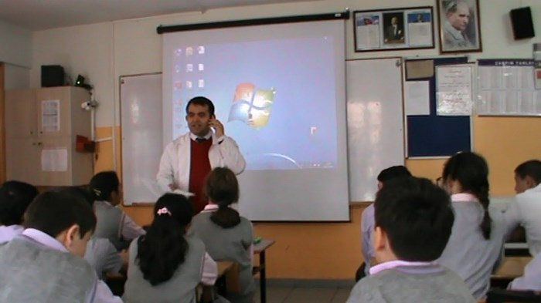
Photo 2: The teacher pretends that he is making a phone call
S: Listen to them. [Altogether]
T: Nobody should listen [to other peoples’ phone conversations]. This is the right to communicate freely/freedom of communication. When I call Ayşe, my mom or my dad and they in turn call me, they should be telling me freely whatever they want to tell. They should not be worrying about other people listening to our conversation or recording it. What shouldn’t they do?
S: They should not worry.
T: They should not worry. Kids I want to tell you about a book I read recently. There is a professor in America and I have just seen his name for the first time on a book while I was walking past a bookstore ten days ago. His name is Howard Zinn. He is an activist and he is against all kinds of human rights violations in America and in the world. He also takes action against the wars America conduct. For years he has done a lot of research on these issues. Eventually, he decides to write his autobiography. But he says “I am more than 80 years old” and he gets confused about how to write his life story. Then kids, eventually he asks the CIA… What is the CIA?
Yavuz: Central Intelligence Agency in America.
T: Yes. Sorry not CIA. He asks the FBI, because the FBI is involved in the internal intelligence within America, for his personal file. He asks the FBI for his personal file and in this file there are all his telephone conversations; all his communicative activities; and everything related to him. And what does this person [Howard Zinn] do with that? What does he do with all what he had forgotten? He writes. He writes everything that he forgot about his life [by using the information from this file]. So, what do we have here in this case? Here we have to do with a person’s or other people’s deprivation of their rights to communicate freely. Do you want your phones to be listened to?
S: No. [Altogether]
T: Do you want your letters to be read by someone else before reaching their destination and somebody licking the envelopes to close them again?
S: No. [Altogether]
T: You do not want that. Do you like sending e-mails? Do you want your e-mails to be read by somebody else who says “Ah, okay this letter is harmless” before they reach the person you have [actually] sent them to?
S: No. [Altogether]
T: Or do you want the pictures on your computer to be stolen by somebody else?
S: No. [Altogether]
T: Or a real incident …. A true story kids... I say it explicitly… a story which was supposed to be in the newspapers so that all people knew about it. Do you want somebody to prevent this story from being published in the newspaper?
S: No. [Altogether]
T: If you do not want those things to happen, you are among the people who support the right to communicate. Ok… the right to defend yourself in a court. Justice and equality. Do you think everybody on the world is equal?
S: No. [Altogether]
T: Is everybody equal in front of the law and the courts?
S: Yes. [One group] No. [One group]
T: So? I do not want to influence you. Those of you who say “equal” raise your hands … Who say “not equal” raise your hands. [The majority is for “not equal”] I am going to ask those of you who said “not equal” why they think this way. Yavuz [pseudonym name used] why [is everybody] not equal [in front of the law and the courts]?
Yavuz: Teacher, what do you mean by “not equal”? Do you mean equal according to me or what the current situation is [what is happening now on this issue]?
T: Whatever you see. Is there any difference?
Yavuz: There is discrimination.
T: Ha?
Yavuz: There is discrimination teacher.
T: Tell me how?
Yavuz: Teacher, for example a thief must be sentenced to 30 years according to the law, but s/he gets only 10 years or a criminal that actually should be sentenced to 20 years gets 30 years.
T: Hmm. You say a criminal who must be sentenced to 10 years gets only 5 years and another criminal that actually should be sentenced to 5 years gets 10 years. Do you mean that?
Yavuz: Yes.
T: So you say there is injustice. What else… So why do they discriminate between two criminals?
Yavuz: I do not know, teacher.
T: Have you heard something like that before?
Yavuz: Yes, we hear about it on the news.
T: You see it on the news. So based on that do you say there is injustice?
Yavuz: Yes.
T: In fact… I do not know whether we can say it based on that… Ok… In fact, it is not right to talk about this based on this reference [based on assumptions]. Why is this not right? In fact, saying something like “this happened this way and that happened that way” is also a deprivation of humans’ rights. When you talk about human rights, it is not appropriate to say “have you ever seen a rich person’s kid spend time in jail?” In fact, using this sentence is a violation of the human rights of all these rich people or many other people who are better off. But there is one thing on the world: “Everybody is equal, but some are more equal!” What does that mean?... Yes, what does that mean? Everyone is equal, some are more equal. What does that mean? Yes.
Bora: Those who have property are richer. Those who are in the upper class are more equal.
T: Why?
Bora: That is what I understand from that.
Yavuz: Teacher, it is actually exactly the opposite. Upper class people are less equal, lower class people are more equal.
T: How? I do not understand.
Yavuz: Teacher, think of a politician’s son and a vagabond/roamer from the folk.
T: Who has more advantages?
Yavuz: The son of the politician, teacher.
T: Ok, you said a good thing. A couple of days ago I was walking here around the school. I saw the police stopping two teenage boys [Sometimes policemen/policewomen stop people to check their IDs and search them in the control point designated by the police. So, although it is not very common, it is not an unusual situation.] The officers said “Come here.” The boys went to them, but unintentionally I had a look at the boys’ clothing. Their clothes were very old and it seemed that they were coming from a certain neighborhood within Istanbul. I mean, their beards and hair… their outfits… as if the officers had seen them like this and stopped them [because of their appearance]. But there were other boys of the similar ages passing by, but the police did not stop them... Why? Have you ever experienced something like that? Tell me.
Senem: Teacher, I don’t know why this happened. The policemen may have thought that these boys were thieves because of their clothing and appearance.
T: So is it enough to assume [that they have done something illegal] in order to stop and search a person on the street in front of everybody?
S: No. [Altogether]
T: I come… [he calls on a male student from the first row] “stand up, stand up, turn around” [talking to him like a policeman]. Let’s say your mother, your wife are there. I do not know… imagine you have your beloved girlfriend or boyfriend with you. But somebody says “turn around, take out your ID” [talking like a policeman] and you say “what have I done?!” “Turn around, take out your ID.” Is this right? Ok, you can sit down. [to the student] Then, is it enough only to assume? So, it is enough to stop somebody only supposing [that they did something illegal]. Ok let’s say in later time… Who says “I do not look like a thief” raise your hands. Those of you who say “I do not look like a thief or a murderer” raise your hands. [everyone raises his/her hand] I also do not look like a thief or murderer, in my opinion. But when I look into the mirror I look like a thief and also like a murderer [laughing]. Anyway, you have not done something like that. So it is not important whether you look like a thief or murderer, you haven’t done such a thing. But let’s say one morning you woke up… randomly you took a [bad/old] jacket, you did not shave your beard, you did not comb your hair. And you did not paint/polish your shoes. And the policeman stopped and searched you and asked you for your ID. How would you feel?
S: … [3 sec]
T: Let me do it this way… let me give you my answer to this question. Then I will take your answers. I would not feel anything. I would say to the officer “Thank you officer. Be always careful like that. Whenever you suspect somebody, you can stop and search him/her.” I would say that. What would you tell them?
S: [Inaudible]
T: What would you do?
SF: I would get embarrassed in the midst of those people.
T: Have you ever gotten embarrassed like that?
Bora: By the police or…?
T: Yes, by the police. Have the police embarrassed you before?
S: [Saying no by nodding negatively.]
T: Did the police ever embarrass you? So, what would you think [if you were treated this way by the police]? Would you get embarrassed or…? Your friend said he would. Would you be embarrassed?... I personally am sensitive concerning this issue. The police should search me… I can be anybody, I can be a bomber. Even when the officer gets bored or suspects me s/he should stop and search me… Even if there is not a policewoman there at the moment, a policeman can search my wife! Because our lives and safety are important. The police is for our safety. That is what I think on this issue. Tell me what do you think? Yes.
SF: I would not get embarrassed, because the police eventually would realize that I did not do anything.
T: Ok. You?
Yavuz: Teacher, it is not about embarrassment. You said the police can do whatever s/he wants, I will collaborate with them. But what if they stop only you and not another person walking by. They should stop everyone.
T: Look what I say. Let’s assume the officers are suspicious of my wife. And right then there is no policewoman there… But people’s health and safety is in danger. So a male cop can search my wife. I would not care.
Yavuz: But teacher, if the police, for example, stopped only me but nobody else on the street, I would get embarrassed.
T: But the officer is only suspicious of you.
Yavuz: Then, I would get embarrassed, because everybody [on the street] would look at me as if I was a thief.
T: Everybody would look at you as if you were a thief. Actually you did not commit any crime. That is what you are thinking about. Though you did not commit any crime people would think of you as a criminal. How would this make you feel? It would…
S: …disturb us. [Altogether]
T: It would disturb you. What else?... What else? I want to hear something from someone who has not spoken so far. Tell me, how would you feel? [asking to a girl in the first row] So you say “I have a pretty and innocent face. Which police would stop me?” [The teacher is teasing the student]
Gamze: Teacher… I would not want everybody to turn back and look at me. Because… I mean… I would not want it. I mean I would get embarrassed.
T: Who says “I would want it and I would get embarrassed”? Raise your hands.
SM: Those who say that they would be embarrassed. [corrects the teachers’ statement]
T: Those who say “I would be embarrassed, I wouldn’t want it.”
S: [The majority raise their hands.]
T: Or the ones who say, like me, “What the heck! It is not worse than dying!” raise your hand. I mean those of you who say “Is it worse than dying? I would not get embarrassed.” raise your hand. Let me say the whole sentence. Those of you who say that they wouldn’t be embarrassed.
S: [Few students raise their hands.]
T: The ones who say “I am undecided. I have not thought about it.” raise your hands.
S: [Few students raise their hands.]
T: Alright. Kids, in fact, I lied to you. I would not want such a thing to happen to me. I mean, if I was certain that I was innocent I would not want the police to stop me and search me in the midst of people. I would not want my wife to be searched inappropriately and undergo an identity check. Because this is not something normal. This is not a normal thing. Imagine experiencing this every day. Every day when you enter school you got searched. When you enter Istiklal Street [a famous street in Istanbul] you got searched; or you just go to the street and you are searched. And people always keep telling you… What do they tell you? “We are doing this for your safety.” You use your phone and hear some noises. You understand that you are wiretapped. So, you complain about that and you are told “Oh no, we do it for a safe society.” Your letters, your e-mails and everything is exposed and read by others. So, one should get disturbed by this kind of action. That is where the expression “human rights” emerges. Here, in this case, human rights are abolished. Let’s continue... The right to search for rights. What is the right to search for rights?... Tell me.
Can: For example, if a person’s rights are violated, s/he has the right to search for his/her rights.
T: Ok, what else?… The right to search for your rights. Is there anybody who feels that his/her rights are violated? At home, at school, at the hospital? For instance, is there anyone who believes that doctors in a hospital do not take good care of him/her? Have you experienced something like that before?
S: …
T: So, you have not. Ok, right to secrecy of private life... What is that?... What is the secrecy of private life?
Can: For example, nobody has the right to know what happens in my home and what I do there.
T: Ok is this violated… in our country?
Can: I do not know, it depends on the person.
T: Ok, do you like paparazzi shows?
Can: No.
T: Who likes paparazzi programs? [a couple of students raise their hands] I like these shows, for instance. It is fun to watch them on Sundays! Why do I like these shows?
S: [Students laughing.]
T: I see all the details of celebrities’ lives like… where they eat, where they go swimming, who they talk to in their houses, what they wear or do not wear. [Bell rings] This is why I like these shows!
Senem: I like them, too.
T: I like them very much! But in fact, by watching these shows I follow other people’s lives without even noticing. I am sitting in front of the TV and am observing other peoples’ lives. We will continue next lesson, kids.

Acknowledgements: I would like to thank to the school principal Yener Şarkoğlu and social studies teacher Engin Yolcu for opening their school to my study and Taner Ezici who assisted me with the video recording. I also would like thank to Yasemin Çidem, Dr. Jennifer Bruen, and Professor Tilman Grammes for their reviews, edits, and recommendation throughout the publication process.

References

Milli Eğitim Bakanlığı Talim Terbiye Kurulu Başkanlığı [TTKB]. (2009a). İlköğretim 1, 2 ve 3.sınıflar hayat bilgisi dersi öğretim programı ve kılavuzu [Life studies curriculum: Grades 1,2,3 and teacher’s manual]. Ankara: author. Retrieved from http://ttkb.meb.gov.tr/ogretmen/modules.php?name=Downloads&d_op=viewdownload&cid=74&min=10&orderby=titleA&show=10

Milli Eğitim Bakanlığı Talim Terbiye Kurulu Başkanlığı [TTKB]. (2009b). Sosyal bilgiler 4. - 5. sınıf programı [Social studies curriculum: Grades 4-5]. Ankara: author from http://ttkb.meb.gov.tr/ogretmen/modules.php?name=Downloads&d_op=viewdownload&cid=74&min=10&orderby=titleA&show=10

Milli Eğitim Bakanlığı Talim Terbiye Kurulu Başkanlığı [TTKB]. (2009c). Sosyal bilgiler 6. - 7. sınıf programı [Social studies curriculum: Grades 6-7]. Ankara: author. Retrieved http://ttkb.meb.gov.tr/ogretmen/modules.php?name=Downloads&d_op=viewdownload&cid=74&min=20&orderby=titleA&show=10

